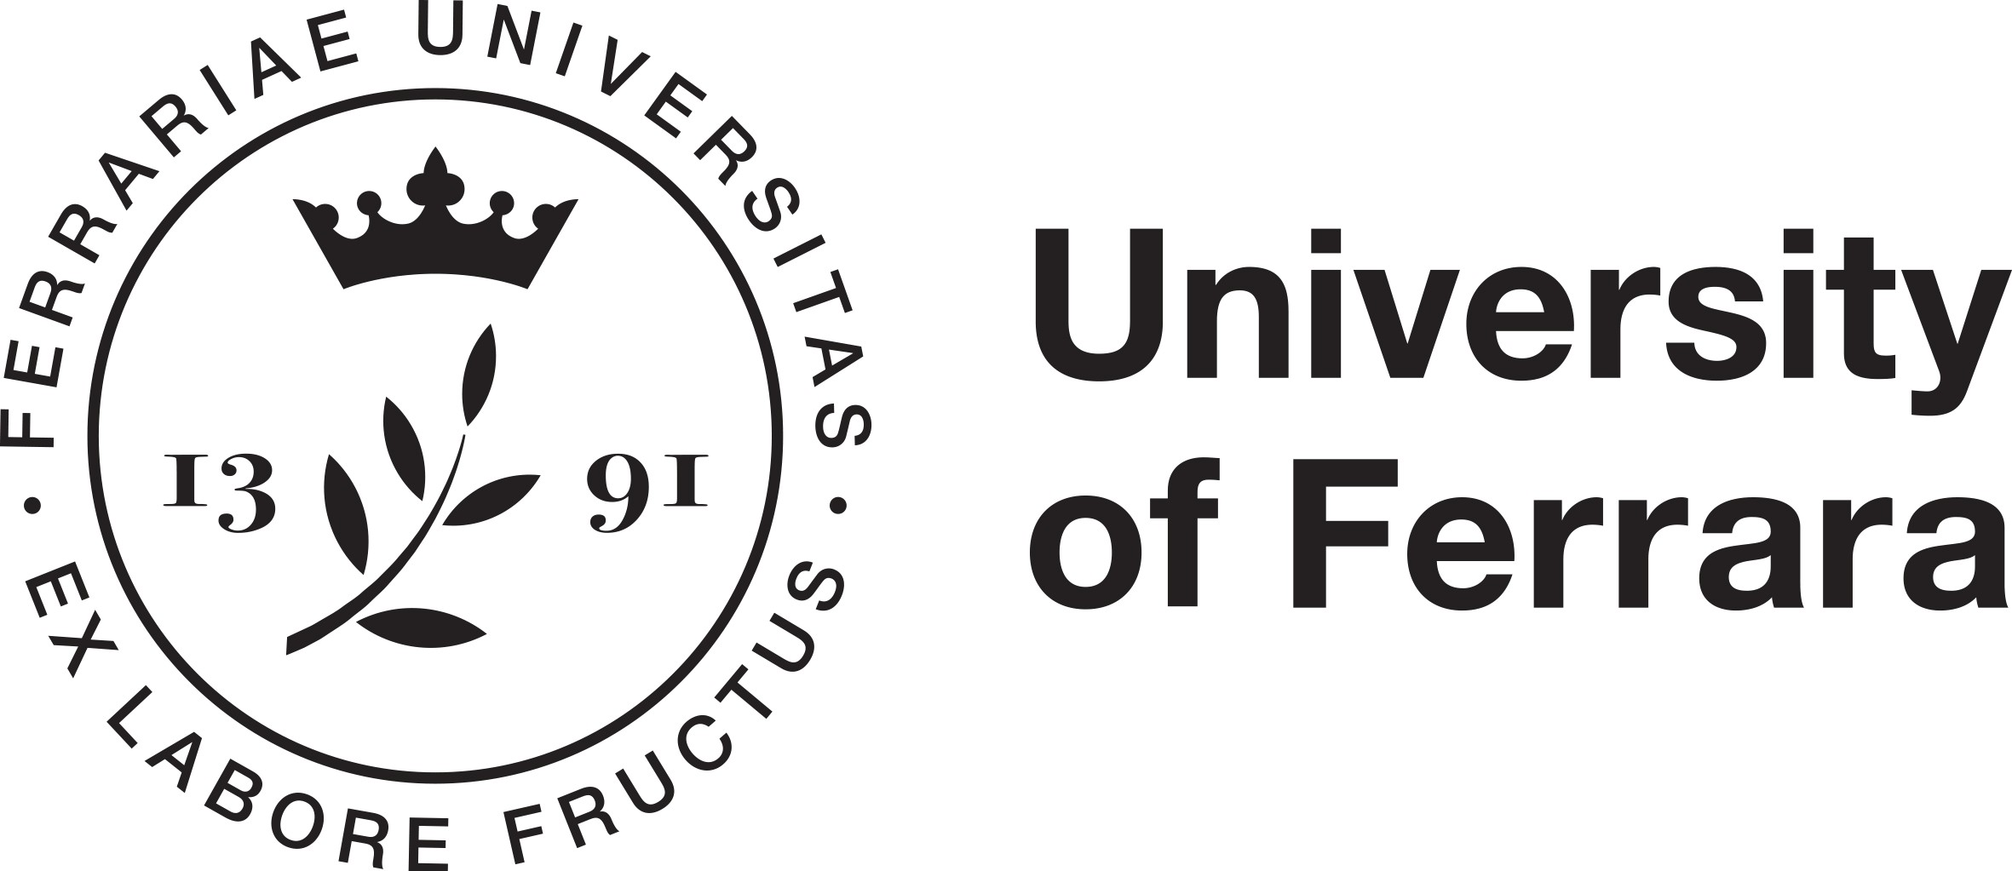

The Value
of Consumer Data
in the Digital Economy

18 and 19 April 2024
University of Ferrara
Via Voltapaletto 11
Aula EC 4

Scientific Committee:
Alberto De Franceschi, Reiner Schulze, Dirk Staudenmayer

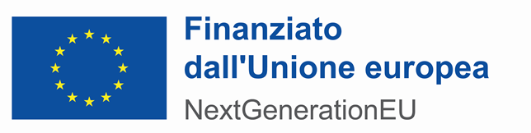

Thursday, 18 April 2024

University of Ferrara, Via Voltapaletto 11, Aula Magna

13:30 Registration
14:00 Welcome addresses
14:15 Introduction
Reiner Schulze (University of Münster)
14:30 I. Trading Consumer Data: Background and General Framework
Chair: André Janssen (Radboud University of Njimegen)

Personal Data as Object of Trade – Options and Limitations under the GDPR
Andreas Sattler (Karlsruhe Institute of Technology)
The Value of Consumer Data – a Common Law Perspective
Christian Twigg-Flesner (University of Warwick)
15:30 Discussion
16:00 Coffee Break

16:30 II. The “Monetisation” of Consumer Data
Chair: Herbert Zech (Humboldt University, Berlin)
“Ius Pretium” – Price Control in General Terms and Conditions
Hans Schulte-Nölke (University of Osnabrück)
Contracts for Monetising Consumers' Data and Mobilising Data Value in the Market
Teresa Rodriguez de las Heras Ballel (University Carlos III, Madrid)

Consequences of the monetisation of consumer data for contract type and contract structure

Martin Schmidt-Kessel (University of Bayreuth)
18:00 Discussion

Friday, 19 April 2024

University of Ferrara, Via Voltapaletto 11, Aula EC 4

09:00 III. The Determination of the Value of Data
Chair: Christiane Wendehorst (University of Vienna) invited
Developing the Data Act: Market Failures, Value of Data, and Consumer
Choice in the B2C Sector
Wolfgang Kerber (Philipps University Marburg)
Determining the Value of Data in the B2B Sector
Fernando Gómez Pomar (Pompeu Fabra University, Barcelona)

Databases as a non-tradeable business asset?
Vincenzo Zeno-Zencovich (Roma Tre University)

10:30 Discussion
11:00 Coffee Break

11:30 IV. Round table: Should the EU Regulate the Fair Share of Consumers in the Use of their Data?

Chair: Dirk Staudenmayer (European Commission)

André Janssen (Radboud University of Njimegen)
Christiane Wendehorst (University of Vienna) invited
Herbert Zech (Humboldt University, Berlin)

12:15 Conclusions

Alberto De Franceschi (University of Ferrara)

***
Should you wish to attend, please register by 10 April 2024.
Info and Registration: dfrlrt@unife.it

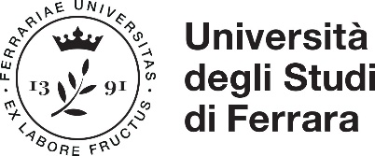
Piano Nazionale di Ripresa e Resilienza
Missione 4 - Componente 2 - Investimento 1.5 Creazione e rafforzamento di “ecosistemi dell’innovazione”, costruzione di “leader territoriali di R&S”
Titolo del progetto
Ecosystem for Sustainable Transition in Emilia-Romagna
Codice CUP
F78H22000410006
Soggetto attuatore
Università degli Studi di Ferrara
Obiettivo principale dell’operazione
- Regulation of the Digital Economy -

