EUSAIR Pillars |  | CENTRAL EUROPE  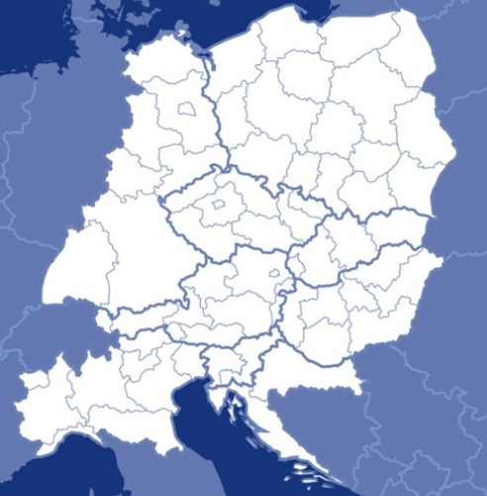 |  | MED  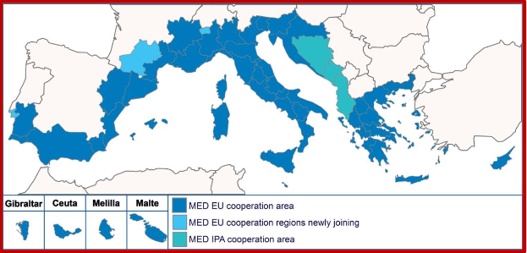 |  | ADRION |  | ITALIA CROAZIA
1. BLUE GROWTH | Blue technologies |  |  | Priority Axis 1:Promoting Med innovation capacities to develop smart & sustainable growth | SO 1.1: To increase transnational activity of innovative clusters & networks of key sectors of the MED area |  |  | Priority Axis 1: Innovation and internationalization |  | SO 1.1: Enhance innovation capacity by cooperation of research & business players in the sectors of the blue economy  SO 1.2: Increase the presence in international innovative markets of blue sector SMEs of the area through joint cross-border actions
1. BLUE GROWTH | Fisheries & aquaculture
1. BLUE GROWTH | Maritime & marine governance and services
2. CONNECTING THE REGION | Maritime transport | Priority 4 – Coop. on transport to better connect CE | SO 4.1 To improve planning & coordination of regional passenger transport systems for better connections to national and European transport networks  SO 4.2 To improve coordination among freight transport stakeholders for increasing multimodal environmentally-friendly freight solutions | Priority Axis 2: Fostering low carbon strategies & energy efficiency in specific MED territories: cities, islands & remote areas | 2.3: To increase capacity to use existing low carbon transport systems & multimodal connections among them | Priority Axis 3: Connected region | SO 3.1: Enhance capacity for integrated transport, mobility services & multimodality in the Adriatic-Ionian area | Priority Axis 2: Low-carbon | Priority Axis 5: Connectivity | SO 2.2: Improve the capacities for mobility planning in urban areas to lower traffic congestion  SO 5.1: Improve the quality & environmental sustainability of maritime and coastal transport services in the area
2. CONNECTING THE REGION | Intermodal connections to hinterland
2. CONNECTING THE REGION | Energy networks | Priority 2 – Coop. on low-carbon strategies in CE | SO 2.1 To develop and implement solutions for increasing energy efficiency and renewable energy usage in public infrastructures  SO 2.2 To improve territorially based low-carbon energy planning strategies & policies supporting climate change mitigation  SO 2.3 To improve capacities for mobility planning in functional urban areas to lower CO2 emissions |  | SO 2.1: To raise capacity for better management of energy in public buildings at transnational level  SO 2.2: To increase the share of renewable local energy sources in energy mix strategies and plans in MED territories |  |  | Priority Axis 2: Low-carbon | SO 2.1: Increase the energy efficiency and the use of renewable energy solutions in housing and public infrastructures in rural, sparsely populated areas
3.ENVIRONMENTAL QUALITY | Marine environment -  Threat to coastal & marine biodiversity | Priority 3 - Coop. on natural & cultural resources for sustainable growth in CE | SO 3.1 To improve integrated environmental management capacities for the protection & sustainable use of natural heritage and resources  SO 3.3 To improve environmental management of functional urban areas to make them more liveable places  SO 3.2 To improve capacities for the sustainable use of cultural heritage and resources | Priority Axis 3: Protecting and promoting Mediterranean natural & cultural resources | 3.2: To maintain biodiversity and natural ecosystems through strengthening the management & networking of protected areas  3.1: To enhance the development of a sustainable and responsible coastal & maritime tourism in the MED area | Priority Axis 2: Sustainable region | SO 2.2: Enhance the capacity in transnationally tackling environmental vulnerability, fragmentation & the safeguarding of ecosystem services in the AI area  SO 2.1: Promote the sustainable valorisation & preservation of natural & cultural assets as growth assets in the AI area | Priority Axis: Environment & culture heritage |  | SO 4.2: Enhance the management of the sea natural resources by public actors for a better environment  SO 4.3: Improve the environmental conditions by use of innovative technologies  SO 4.1: Increase the development of the area’s natural & cultural heritage assets also as support to sustainable tourist destinations
3.ENVIRONMENTAL QUALITY | Marine environment - Pollution of the sea
3.ENVIRONMENTAL QUALITY | Transnational terrestrial habitats and biodiversity
4.SUSTAINABLE TOURISM | Diversified tourism offer (products & services)
4.SUSTAINABLE TOURISM | Sustainable & responsible tourism management (innovation & quality)

EUSAIR CROSS-CUTTING ISSUES | CENTRAL EUROPE |  | MED |  | ADRION |  | ITALY-CROATIA
Capacity Building |  |  | Priority Axis 4: A shared Med Sea | SO 4.1: To support the process of developing multilateral coordination frameworks and strengthening the existing ones in the Med for joint responses to common challenges | Priority Axis 4: Supporting governance of the EUSAIR” | SO 4.1: Facilitate the coordination and implementation of the EUSAIR by enhancing institutional capacity of public administrations and key stakeholders and by assisting the progress of implementation of joint priorities
Climate Change mitigation & adaptation  Disaster risk management |  |  |  |  |  |  | Priority Axis 3: Climate change & risk management | SO 3.1: Increase the adaptation capacity to climate change in the cooperation area  SO 3.2: Increase the capacity for joint risk management in the cooperation area
Research & innovation  SMEs | Priority 1 - Coop. on innovation to make CE more competitive | SO 1.1 To improve sustainable linkages among actors of the innovation systems for strengthening regional innovation capacity in CE  SO 1.2 To improve skills & entrepreneurial competences for advancing economic and social innovation in CE regions |  |  | Priority Axis 1: Innovative and Smart Region | SO 1.1: Support the development of a regional Innovation system for the AI area”

