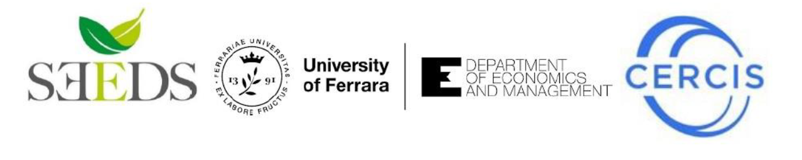
“CERCIS in Bloom- Circular Economy and Transition”
Ferrara, 10 May 2021 (virtual online)

The Centre for Research on Circular Economy, Innovation and SMEs (CERCIS) and SEEDS (Sustainability, Environmental Economics, and Dynamics Studies) of the University of Ferrara are glad to announce their joint organization of an international Webinar titled
“CERCIS in Bloom - Circular Economy and Transition”
Program
10:00 – 10:30 | Opening address  Prof. Massimiliano Mazzanti  University of Ferrara, Director of SEEDS and Head of CERCIS  Prof. Laura Ramaciotti  University of Ferrara, Director of the Department of Economics and Management
10:30 – 11:10 | Keynote lecture 1  Dr. Oriana Romano - “The Circular economy transition across levels of government: an OECD perspective”  OECD
11:10 – 11:50 | Keynote lecture 2  Dr. Silvia Grandi - “Sustainable Finance and Circular Economy”  University of Bologna
11:50 – 12:30 | Keynote lecture 3  Prof. Will McDowall - “Publicly available data understates taxpayer support for innovation in fossil fuel extraction”  University College London

Interested audience is warmly invited to register by Sunday May 9th – 6:00 PM CEST
https://forms.gle/5bLtoHPCYbWxZp8A9

